Diamond Court Dental Practice
Patient Survey 2016

INTRODUCTION

We constantly strive to improve the service that we provide to our patients and strongly value all forms of feedback. Our annual patient survey plays a crucial role in identifying the areas in which we are performing well and also areas where we could improve.

METHOD

Patients with a valid e-mail address who had attended our practice from August 2015 to August 2016 were invited to participate in our survey. The survey was carried out in the form of an e-survey with participants receiving an e-mail containing a direct link to the survey form. All responses were assessed in an anonymous fashion.

RESULTS

Responses were received from 36 patients.

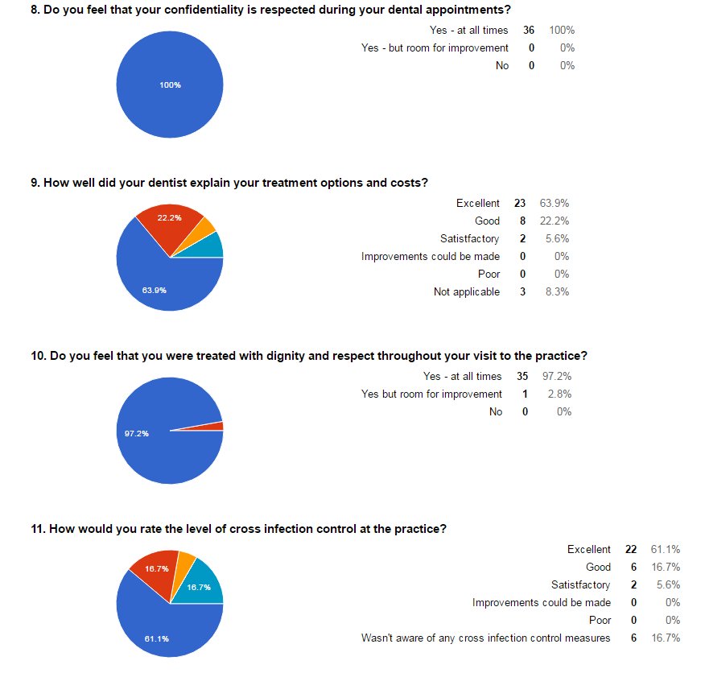

GENERAL COMMENTS:

- This is an excellent dental practice!
- I have been a client for nearly 20 years. I have never had any reason to complain – always on time and very professional (Jamie) and prior to him Joanne.
- The service I receive from the surgery, and especially my appointed dentist (Mrs Read) and the team is exemplary. I have total confidence that everything is being done to maintain my dental hygiene in order that I’ll retain my natural teeth for as long as possible. The entire team are to be congratulated for their highly professional service and the way they operate the dental practice.
- The reception staff seem distant. Not as warm or welcoming as one might expect.
- Mr Chalmers is a fab dentist. Very professional, very friendly. Delighted with the practice.

DISCUSSION

Participation in the survey was lower than last year and completed responses were received from 36 patients. This is similar to the number of responses from previous years.

The results of the survey were extremely encouraging with a strong majority (>90%) of respondents selecting “good” or “excellent” for each question. Compared to the results of the patient survey carried out last year, standards can be seen to have improved in most areas.

An exception to this was a small decline in the number of people who rated the information in our waiting room as “excellent” or “good” with an increase in the number of patients choosing “satisfactory” instead for this particular question. Given that there haven’t been many changes to our waiting room since last year, it is difficult to explain this result and so further patient feedback is required in the future so that we improve this area of the practice.

Several respondents took the opportunity to provide specific feedback in the general comments section of the survey and again the majority of the feedback was positive.

The only negative comment was that our reception staff seemed distant and not very welcoming. This was very disappointing given that our practice ethos is to make dental appointments a pleasant experience with patient comfort and care being our priority. In light of this feedback, we plan to arrange a staff training session focusing on patient communication and how we can improve on a patient’s experience at the practice.

The results of previous patient surveys have raised concerns about appointments being cancelled at short notice and also the use of iPads to complete patient forms in our reception area. It was reassuring to find no comments or complaints in this year’s survey on either of these subjects which hopefully suggests that the changes we have implemented as a practice have resolved these previous concerns.

ACTION PLAN

- To repeat the question “How would you rate the information available in our waiting room?” in next years patient survey and add an extra component to the question asking respondents to explain their selection.

- To arrange a staff training session on patient communication and improving a patient’s dental experience.

