Diamond Court Dental Practice
Patient Survey 2018

INTRODUCTION

We constantly strive to improve the service that we provide to our patients and strongly value all forms of feedback. Our annual patient survey plays a crucial role in identifying the areas in which we are performing well and also areas where we could improve.

METHOD

All patients attending our practice were invited to participate in our survey. The survey was carried out in the form of an e-survey where participants, who had previously given permission to be contacted for this purpose, received an e-mail containing a direct link to the survey form. A link to the survey was also posted on the practice website and Facebook page. All responses were assessed in an anonymous fashion.

RESULTS

Responses were received from 186 patients.

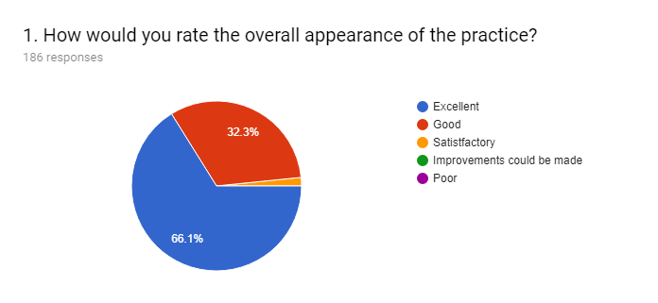

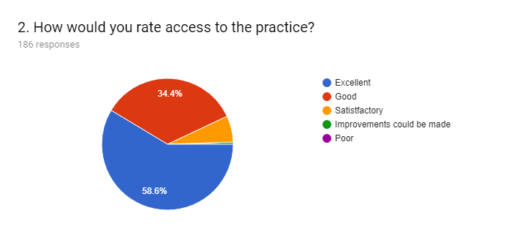

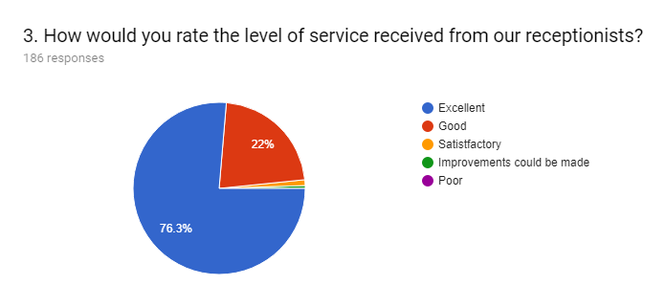

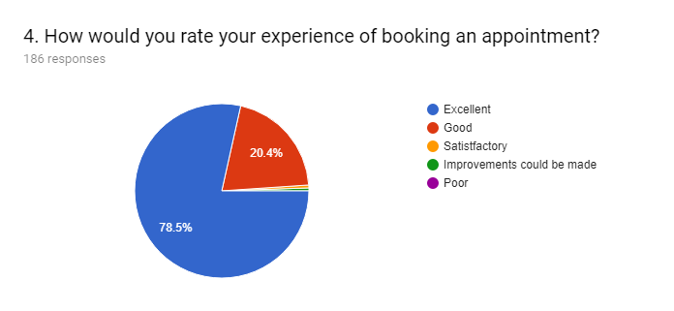

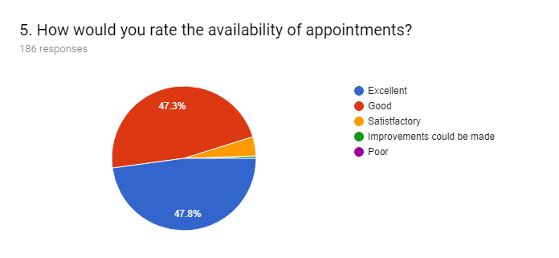

6. We have recently upgraded the information screen in our waiting room. What information would you like to see on the screen?
56 responses

I don't really know!
Not sure.
Amounts of sugar in chocolate and drinks
I think it's very informative with helpful advice about dental problems.
Tips on brushing teeth/dental hygiene
Sorry, I have not noticed the screen.
Tariff of charges
Satisfied with the present information
Dental services and technical information
Dental healthcare information videos.
Hygiene
Didn't notice the information screen!
Waiting time
Waiting time and tips on mouth hygiene?
None
Waiting times if there is likely to be a delay?
Other health services available e.g. live life better Derbyshire
Information about gum recession
Time
How long to wait for appointment (i.e. If appointments are running late etc.)
Wait times for the dentist
It's fine as it is
The information I’ve seen on screen is informative regarding dental treatments available
Non-commercial health information
none
No idea, didn’t notice it
Charges, tooth decay info, sugar damage, opening times, emergency info.
More information on Your teeth and diabetes.
If there is a delay, then it would be helpful to know how long.(having said that I have no complaints)
Sorry, can’t think of anything
not needed
Information around diabetes, heart disease and obesity and how patients can get involved with their care
unimportant
Don't remember seeing it
not really of interest
Nothing in particular
advice on dental hygiene and new products
The present presentation is fine
news channel
Top tips
Waiting time if appointments are running late
General health information and links to local services that provide support for good health — from pharmacies to local activity sessions to weight loss groups
Information about dental care, new techniques and available treatments.
promotions
Nothing
Not seen it yet but expected delays to appointments?
info related to dental health and perhaps other general health items such as sharing patient info (see below)
Sorry I only have an annual appointment and I haven't noticed the screen but would appreciate it if it would inform us of a delay if that should be the case.
I thought the info was clear & easy to read, so at the moment I don't think it needs changing.
No additional requests
Interest general facts
I find the information interesting most of the time
If the dentist was running to the appointments schedule, if possible?
Cartoons
Maybe a news channel, waiting and watching each other can feel awkward and boring
Information about the various treatments and prices are always interesting.

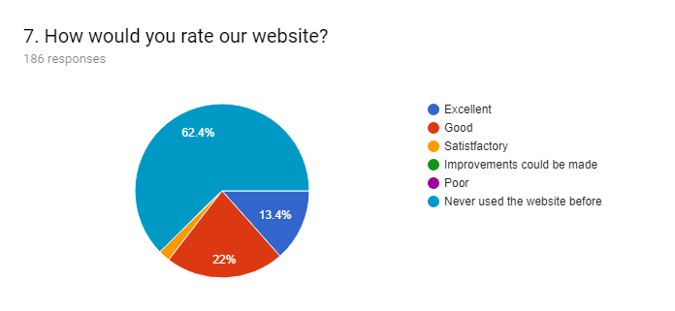

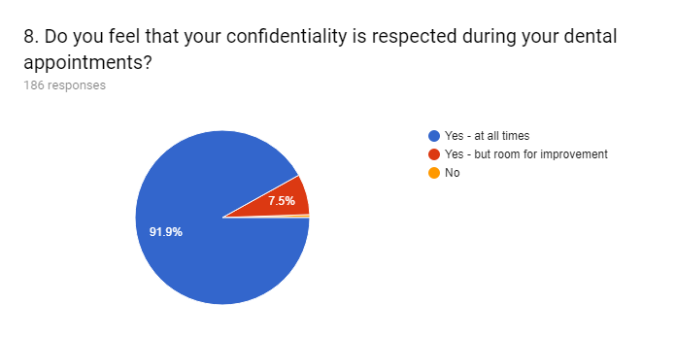

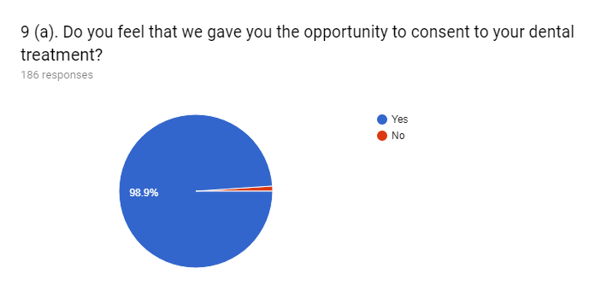

9 (b). If you answered "No" to the previous question please give further details to explain the reason behind your answer.
2 responses

On some occasions I have not felt I have been given options concerning treatment, and been told " it's not a question of what but when" leaving me feeling intimidated.
It was advice needed rather than treatment.

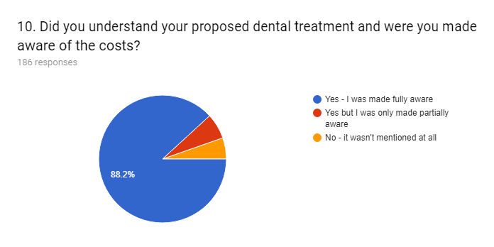

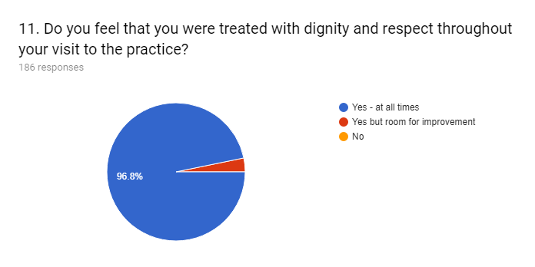

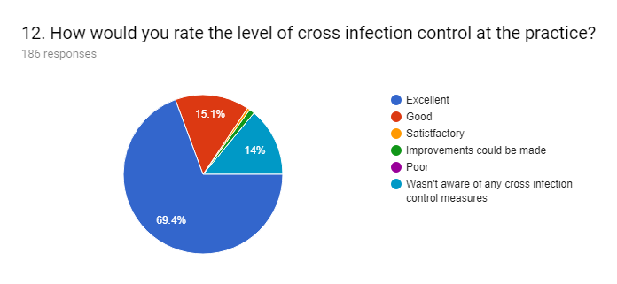

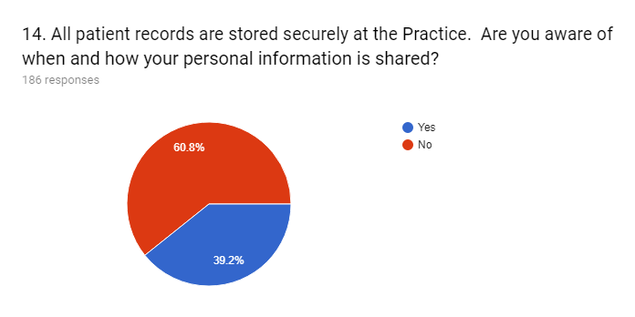

15. We aim to ensure that all patients get information that they can easily access and understand. To help with this we have induction loops that are widely available to all patients and all our Practice-based literature is available in large print, easy read and braille. Please give details on any further suggestions you have on how we could improve communication with our patients.
19 responses

None (4)
It all seems absolutely fine to me
I liked having a phone call to remind me the day before an appointment, and would like this reinstated.
The reminder texts are very useful.
I personally know some members of staff so I can ask them if I'm unsure about something
None to give
Publicise web site and if not already there put information about treatment and pricing there.
Not Applicable
I wasn’t aware of this literature
none
I have no problem with communication
I've had no problem with communication.
No comment
No suggestions
Perhaps a newsletter would be helpful.
No additional requests

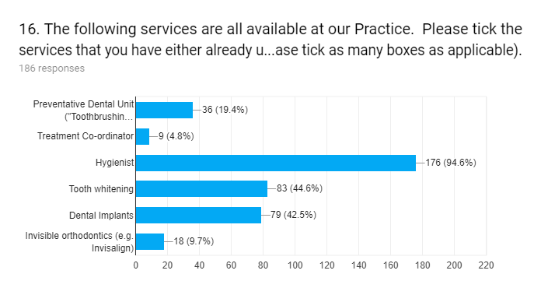
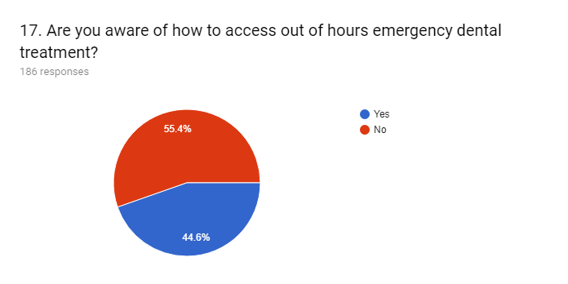

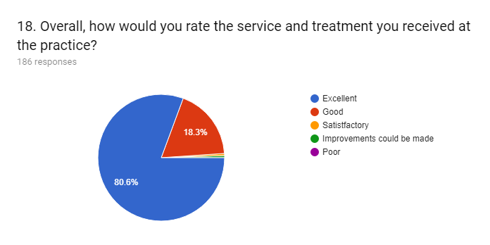

GENERAL COMMENTS:
36 responses

I'm completely satisfied with the service and treatment that I've received at Diamond Court Dental Practice.
Easier access to emergency treatment and problem referred to regular dentist who knows the patient and can make an informed decision or advice. Excellent dental care and excellent relationships with patients. Excellent practice overall and I would strongly recommend Diamond Court to others.
Very professional treatment throughout.
We are very pleased to have Diamond Court as our dental practice. Thank you
I tend not to 'notice' things unless there is a problem. eg: cross infection, out of hours. Would it be an idea to have a leaflet for each patient with this sort of information.? Perhaps you already do and I haven't noticed that either!
I’m extremely satisfied with the professional service I received at Diamond Court and would have no hesitation recommending the practice
Service excellent as usual very welcoming and professional
Patients should be able to go on a waiting list for NHS Treatment
First rate practice with consistently great service
I was always scared of the dentist and lost many teeth because of it but since I have been at this practice I feel at ease and look after myself now .
An extra box is needed for a "non-applicable" answer to some questions in this survey.
I feel unable to answer question 12 because I am not really aware of what cross contamination measures you use. Having said that I assume that each patient is treated with cleaned equipment and the surgery always looks spotlessly clean to me. I have always been happy with the treatment that I have received from Paul Flint.
I would find it impossible to fault anything at Diamond Court. I'm very grateful to be able to receive NHS treatment from Jamie who is an absolutely fantastic dentist!!
If the dentist is running 15 or more minutes late a courtesy text or call would be appreciated.
Please see my email I have sent with this survey
Sarah, the dental hygienist, is excellent at giving great explanations/advice on how to improve dental hygiene. My teeth/gums have improved considerably since having appointments with her, many many thanks to her
During my appointments at the surgery, other staff are in and out for various reasons. It is distracting when the door keeps opening and closing.
This questionaire has been very badly constructed. Who ever put it together is only interested in getting the RIGHT answer for the practice or who is a complete novice, or possibly both.
I am leaving this practice to go to a private dentist in Chesterfield. He identified several areas of decay (which I could see on his photos) which Diamond Court hadn’t noticed. I felt I was treated lie a naughty child if my teeth weren’t spotless and I don’t need this. I’m a pensioner who has just come through cancer so I’d rather pay and feel respected and valued as a patient
Thank you for an excellent service.
I am very very happy with the treatment provided, and the Dentist's, just wish they had been available when I was younger I would have better teeth then. I am a N.H. patient aged 77
please with treatment
I find it a very friendly helpful dentist practice, all the staff I have come into contact with are professional, friendly and polite. I am happy with my current dentist who is very good with me as I don’t like going to the dentist.
A very well run dental practice, which I am happy to continue to use.
I find my Dentist, Mrs Denholm and Nurses very friendly and helpful.
Good to have a dentist who listens to my problems and is friendly and whose professional competence I can trust
Am very satisfied with the dental treatment I and other family members have received at Diamond Court. Thank you.
Questions 9 & 10 were difficult to answer as I had no treatment. I also have Denplan so most treatment is paid for.
Even more important to me - the treatment I have received in the last 12 months has been very successful. This has included a root canal filling and a crown.
Re out of hours emergency .... just have fortunately never needed, so not a criticism. Guess info on www ??
I find the method of signing the computerised forms irritating, confusing and time consuming as they don't always work the first time.
I did have difficulty out of hours the website said "open". I was waiting outside until a local trader said they were closed. I did speak to the practice and they apologised and acted immediately. They are very efficient.
Reception desk; I am aware that when I am making an appointment or paying for treatment that the next patient (if there is one) occasionally stands close behind me. Close enough to see, if she/he wishes may see my PIN and next appointment date, if one is necessary. There is a little uncomfortable feeling of being watched. If there is only one patient in front of me, I stand with my back to the wall facing the Reception Desk. If another patient comes I move forward to the desk to maintain my position in the queue. so, I cannot see an immediate answer, except to post a notice asking patients to respect the privacy of other people.
The care and treatment I have received over the years has been professional and personal and has gone a long way to improving my wellbeing far beyond what would be normally expected from dental care. Some of the advice and guidance I have been given has improved my life considerably .
Would appreciate being informed immediately upon arrival if the dentist is running late (and by approximately how late) and my appointment therefore likely to be delayed - not complaining if that is due to unforeseen circumstances, but it is frustrating being kept waiting without knowing whether it’s for 5 minutes or half an hour.
Thank you all for looking after us both. Much appreciated.

DISCUSSION -

The results of the survey were extremely encouraging with a strong majority (>95%) of respondents selecting “good” or “excellent” for each question and more than 98% giving the Practice an overall rating of either excellent or good. Compared to the results of the patient survey carried out last year, standards can be seen to have at least been maintained or improved in each area.

Participation in the survey was significantly better than any survey that we have done before and completed responses were received from 186 patients. This is more than double than the number that we received last year and is likely to be due to the introduction of GDPR (General Data Protection Regulations) where we now have to seek each patient’s permission to send them the survey. This means the only patients to receive the survey were those that had expressed an interest in doing so.

The survey suggests that the majority of patients still aren’t familiar with how their personal information is stored and used at the Practice. Following the implementation of GDPR earlier on in the year we have started displaying information in our waiting room in an attempt to raise awareness of this subject. Our summer newsletter also focused on GDPR and its impact on patients.

Several respondents took the opportunity to give suggestions for new content for the information screen in our waiting room and we aim to implement some of these suggestions in the near future. Many patients also gave specific feedback in the general comments section of the survey and it was very pleasing that the vast majority of the feedback was positive.

One patient expressed concern about the lack of privacy at our reception desk, particularly when there are several other patients waiting at the same time. We recognise this makes confidentiality difficult and we have made our old records room available to patients to use should they wish to discuss confidential issues. The lack of space around the reception desks means it isn’t feasible to introduce a barrier or formal queuing system and so we have placed a sign on reception asking patients to politely respect each other’s space and privacy.

A number of patients requested to be kept better informed if their dentist or hygienist is running late. Whilst every attempt is made to run to time occasionally unavoidable complications and emergencies arise which can mean that clinicians run late. We have discussed this issue at a recent staff meeting and all clinicians have been asked to keep our reception staff informed if they are running more than 15 minutes late so this can be passed on to patients.

Another patient commented that several members of staff seem to enter the surgery during their appointment which can be distracting for everyone concerned. One of the main reasons for this is the collection and delivery of instruments which are sterilised and packaged in our dedicated decontamination room. We do, however, recognise that such interruptions aren’t ideal and we do try to restrict the number of times instruments are collected and delivered to an absolute minimum.

Finally, some patients left feedback on the design of the annual patient survey. One patient felt that there should the option to select “not applicable” as an answer to some of the questions and we aim to implement this for the next survey. Another patient felt the survey was designed badly and in such a way that only the “right” answers were chosen to make the Practice look good. We would like to stress that this is not our intention and the aim of the survey is to identify what we are doing well and where we need to improve. The survey is done in-house to help keep down running costs and we would welcome and constructive feedback on how the survey could be improved or designed better.

ACTION PLAN

- Display a sign on our reception desk asking patients to respect one another’s space and privacy

- Clinicians to keep reception staff informed of anticipated waiting times

- Introduce new slides on information screen in the waiting room

- Repeat the patient survey next year (Summer 2019)

